Families of Elements Web Quest
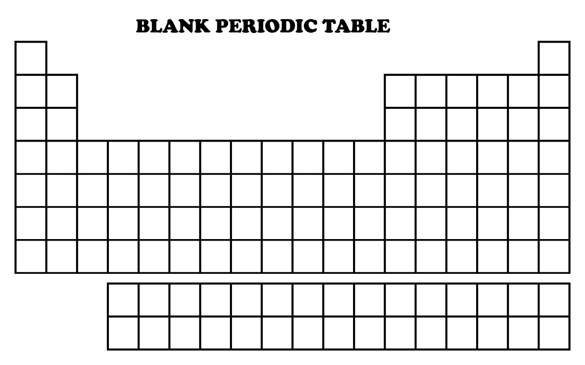
KEY
Alkali Metals
Alkaline Earth Metals
Transition Metals
Halogens
Noble Gases
Lanthanides
Actinides

Go to: www.chem4kids.com/files/elem_families.html

- How do scientists groups families of elements?

Click on the link to alkali metals on the right.

Alkali Metals

- Which column are the alkali metals? Colour the alkali metals on the blank periodic table.

- What group do the alkali metals belong to?

- Name the six alkali metals.

- What is a trait that all these elements share? Why do they have this trait?

- What are some of the physical properties of the alkali metals?

Click on the link to alkaline earth metals.

Alkaline Earth Metals

- Which column are the alkaline earth metals? Colour them on the blank periodic table.

- What group do the alkaline earth metals belong to?

- Why are they called alkaline metals?

- Name the six alkaline earth metals.

- What is a trait that all these elements share?

- Which of these elements is radioactive and what did it used to be used for?

- Why are calcium and magnesium both important to animal and plant physiology?

Click on the link to halogens.

Halogens

- Which column are the halogens? Colour the halogens on the blank periodic table.

- What group do the halogens belong to?

- Name the five halogens.

- What do all the halogens have in common? Why does this make them so reactive?

- Which halogen is the most reactive?

- What happens to the reactivity as you move down the group?
Click on the link to noble gases.

Noble Gases

- Which column are the noble gases? Colour the noble gases on the blank periodic table.

- Which group do the noble gases belong to?

- Why are the noble gases non-reactive?

- Name the six noble gases.

- What are some of the uses of noble gases?

Click on the link to transition metals.

Transition Metals

- What makes the transition metals special?

- Transition metals can have more than eight electrons in the shell one in from the outermost shell. What is the maximum number of electrons transition metals can have in the second-to-last shell?

- What is a chemical trait that allows transition metals to bond with many elements?

Click on the link to lanthanides.

Lanthanides

- Colour the lanthanides on the blank periodic table.

- Which elements make up the lanthanide series?

- Where might you find some of these elements?

Click on the link to actinides.

Actinides

- Colour the actinides on the blank periodic table.

- What makes the actinide series different to the lanthanides?

- Which elements make up the actinide series?

- What are the elements plutonium, uranium and americium used for?

- Colour the remaining transition metals on the blank periodic table.

